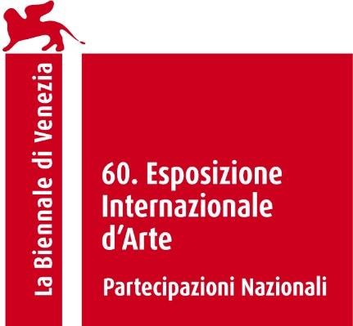

The Slovak Participation
at the 60th International Art Exhibition – La Biennale di Venezia
Czech and Slovak Pavilion

Floating Arboretum
Commissioner: Monika Krčmárik
Curator: Lýdia Pribišová
Exhibitor: Oto Hudec

Oto Hudec's site-specific project Floating Arboretum curated by Lýdia Pribišová will, due to its nature, be presented in the exterior space of the Czech and Slovak Pavilion in the Giardini at the 60th International Art Exhibition of La Biennale di Venezia.

Floating Arboretum works with an archive/database/file of stories, telling of a collective effort when a united community of activists prevented deforestation, felling, and the destruction of trees. The artist is an activist himself and has actively participated in several protest actions. A recurring motif in Oto Hudec's work is escapism, the desire to save what it is almost impossible to save in a given world, in a given civilizational setting, through flying, swimming, ships, or spacecraft. Even the trees in the Giardini, in Venice, are threatened with extinction due to climate change and rising sea levels. Oto calls for their rescue, as well as for the rescue of other endangered trees in the world. He contemplates an arboretum, a symbolic utopian place, a sanctuary for trees threatened by human expansion and extractivism. The project is an imaginative glimpse into a utopian future in which we select and save trees by moving them to a safe (fictional) arboretum. Different timelines intersect here, the present protests against deforestation, the felling of trees in different parts of the world, the climate crisis, and the imaginary utopian future of saving them. The arboretum is an ideological power constructs that need to be viewed from a decolonizing perspective. It is in this postcolonial context that Oto Hudec turns the concept of the arboretum upside down, presenting it as a form of salvation in a time of collapse of native ecosystems.

The trees are painted by Oto Hudec directly on the façade of the pavilion. The mural is accompanied by an installation of a boat with a sculpture of a seed of the Arolla pine, an endangered species native to Slovakia. The stories of Floating Arboretum were poeticized by Juliana Sokolová and sung in a sound piece Songs for Planetary Articulation composed by Fero Király. The performance was choreographed by Petra Fornayová and the costumes were created by Michaela Bednárová. Anyone can get involved in Floating Arboretum via https://floatingarboretum.sng.sk, where they can nominate for rescue their choice of any specific tree with an upsetting fate. We believe that Floating Arboretum's stories can spark transformative imagination and can be inspirational in our everyday lives.
Oto Hudec (1981 Košice, Slovakia, where he lives and works) is a multi-media artist who created and exhibited his recent works in Slovakia, Austria, South Korea, Cabo Verde, Italy, Portugal, and the USA. He creates videos, murals, animations, sculptures, sound pieces, and works for public spaces on the subjects of immigration, refugees and the effects of globalization on the environment. His projects often include a utopian perspective as a way to understand the production of food and energy, tracking transformations of the industrial landscape or the decline of bees. His research on the topics of climate change and ecology is often focused, instead of on new scientific solutions, on how nomadic and indigenous people achieved sustainability. He often collaborates on projects with children and youth from disadvantaged communities. Since 2013, he has been working on a participatory project with Roma children in Slovakia, Project Karavan, together with Daniela Krajčová. Currently an Associate Professor at the Faculty of Fine Arts, Technical University, Košice, Slovakia, he is represented by the Gandy Gallery, Bratislava. His works have been presented both as solo shows and as part of numerous group exhibitions in Slovakia and abroad. Recently, his projects were presented in the Gandy Gallery, Bratislava, Slovakia (2024); East Slovak Gallery, Košice, Slovakia (2022); AlbumArte, Rome, Italy (2022); Biennale Zielona Góra, Poland (2022); Ludwig Museum, Budapest, Hungary (2022); Kunsthalle Bratislava, Slovakia (2021, 2019, 2017); tranzit.sk, Bratislava, Slovakia (2021); Centre Pompidou, Paris, France (2017); De Appel, Amsterdam, Holland (2017); and in many others.

Czech and Slovak art together in one pavilion
The Czech and Slovak pavilion for this year's Biennale Arte presentation is temporarily refurbished so that Czech Republic and Slovak republic can present the contemporary art created in both countries. The entire reconstruction of the building, will occur by the beginning of 2026, when we remember a centennial anniversary of the first opening of the Czechoslovak pavilion in 1926.
At the 60th International Art Exhibition of La Biennale di Venezia, after a long time, the Czech Republic and the Slovak Republic are presenting the projects by Czech artist Eva Koťátková and Slovak artist Oto Hudec in the same pavilion, owned by the two countries.
Inside the Pavilion The heart of a giraffe in captivity is twelve kilos lighter by Eva Koťátková tells the story of Lenka the giraffe, drawing on the history of Czechoslovakia’s acquisition of animals from the Global South in 1950s. Interpreted through contemporary ecological and decolonial perspectives, the project builds a space for imagining different way of relating to nature nowadays. Project is curated by Hana Janečková and created in collaboration with Himali Singh Soin, David Soin Tappeser (Hylozoic/ Desires), Gesturing Towards Decolonial Futures and groups of children and older people.

General Partners:
Kunsthalle Bratislava Gandy Gallery

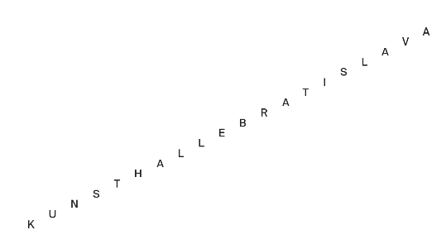

Tatra banka


Supported by:
Ministry of Culture of the Slovak Republic

Contact:
Zuzana Dzurdzíková
PR manager
zuzana.dzurdzikova@sng.sk
+421 911 334 560
Follow us:
- Facebook
- Instagram
- Linkedin

